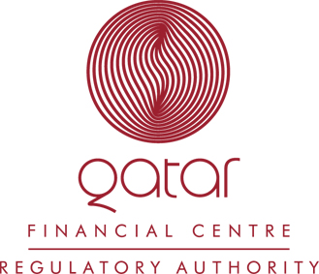
QFC Regulatory Authority Announces Fellowships for Qatari Nationals

Qatar, July 12th 2005: The QFC Regulatory Authority announces the establishment of a prestigious one-year Fellowship Programme for exceptional Qatari Nationals. The purpose of the Fellows programme is to provide gifted and highly motivated young Qatari men and women with first-hand experience in the process of operating and managing a world-class regulatory organisation and personal involvement in the development of the Qatar Financial Centre. The members of the Selection Committee for the Fellows Programme are the Chairman of the QFC Authority H.E. Sheikh Mohammed bin Ahmed bin Jassem Al Thani and the Chairman and CEO of the Regulatory Authority, Phillip Thorpe.

Commenting on the announcement of the Fellowship Programme, H.E. Sheikh Mohammed noted “The QFC is an important part of the Government’s plans for developing the economy of Qatar and will add financial services capacity and create many new opportunities for businesses and individuals in Qatar. The Regulatory Authority’s Fellowship Programme is an excellent example of the benefits that Qatari citizens can expect to see emerge from the QFC.”

Mr Thorpe added, “In creating the Programme we are recognising that there will be an increasing need for financial services professionals in Qatar and in particular for individuals with the skills and experience to implement internationally recognised regulatory and compliance standards. We expect our Fellowship Programme to help create a cadre of individuals that can work not only with the Regulatory Authority but who may also develop careers with the firms that will establish within the QFC.”

The Qatar Financial Centre has been established by the Government of Qatar to offer a world-class financial services environment to international businesses and to stimulate the growth of the Qatari financial services sector. The QFC Regulatory Authority is an independent financial regulator supervising banking, insurance, securities and derivatives trading, asset management, Islamic institutions and related financial services. Its rules and regulations are based on the highest international standards and reflect global best practices.

Successful applicants will be employed full time by the Regulatory Authority and will receive first-class, hands-on experience in regulatory practices in the various QFC Regulatory Authority functions such as Policy Development, Authorisation, Supervision and Legal and Regulatory Compliance.
The Regulatory Authority is seeking Qatari National applicants with excellent academic records between the ages of 21 – 26 who have graduated, or will graduate at the end of the 2005 academic year. Applicants should have majored in relevant subjects such as Accountancy, Law, Economics or Business Administration. Applicants will be evaluated based on their leadership qualities, analytical skills and communication abilities.

Interested applicants are encouraged to submit a copy of their CV and the completed Fellowship Application Form (available on www.qfcra.com) along with all required attachments to QFC Regulatory Authority, attn. Ms. Caroline White.

For more information on the QFC Regulatory Authority, please visit www.qfcra.com.

