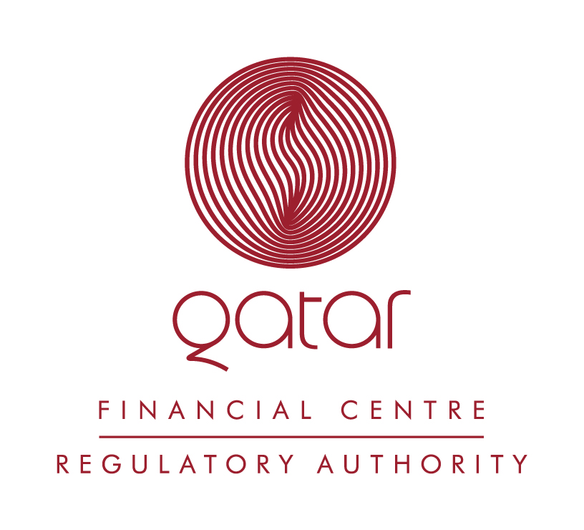

PRESS RELEASE

QATAR FINANCIAL CENTRE regulatory Authority issues rulebook on islamic finance for public comment

DOHA, 31 July 2005

The Qatar Financial Centre Regulatory Authority (“Regulatory Authority”) has issued for public comment a draft Rulebook on Islamic Finance that will govern Islamic financial operations in the Qatar Financial Centre (“QFC”) and sets out the requirements for firms undertaking Islamic financial business. The Regulatory Authority is responsible for the development and administration of the rules applicable to financial services activities regulated under the QFC Law (9 March 2005) and Financial Services Regulations (17 May 2005) (“FSR”).

The Regulatory Authority seeks comments on these rules from the international financial and legal community prior to their adoption in accordance with Article 15 of the FSR. Comments are requested within the next thirty (30) days and may be forwarded to the Regulatory Authority. Contact details for the Authority can be found at www.qfcra.com.

Commenting on the issuance of these draft rules on Islamic Finance, Phillip Thorpe, the Chairman and CEO of the Regulatory Authority, noted:

“The draft Islamic Finance Rulebook is a key component of financial services regulation in the QFC, and will provide a comprehensive regime for all aspects of Islamic financial business conducted in or from the Centre. Along with the draft Regulations issued for comment today by the QFC Authority, the draft Rulebook will ensure that the QFC provides an open yet robust financial environment that operates to the highest international standards.”

The Regulatory Authority expects to publish for public comment in the coming weeks revised draft Rulebooks on Principles, Assets, Controls, Conduct, Individuals and Interpretation and Application, and new draft Rulebooks on AML and data protection. All Rulebooks and draft Rulebooks issued for comment are available on the website of the Regulatory Authority (www.qfcra.com).

Media Contact:
Jamie Orchard
Chief Operating Officer and MD Legal and Regulatory Compliance
QFC Regulatory Authority

Telephone: +974 494 5491
Mobile: +974 5202481
Email: j.orchard@qfcra.com

Notes to Editors:
Qatar has recently established the Qatar Financial Centre. On the 9th March this year, new legislation was ratified enabling the QFC to have an internationally recognisable, best-in-class business and legal infrastructure run by a commercial authority and an independent regulatory body, the QFC Authority and the QFC Regulatory Authority respectively. The QFC formally opened for business on the 1st May 2005, and is now receiving applications.

